Experiment No.: 07 Date: / /

Half Adder and Full Adder
AIM: Write VHDL code for Half adder and Full Adder using data flow modeling style, synthesis, simulate it and verify its functionality.

EQUIPMENTS & COMPONENTS:
1) Computer with Xilinx Software / Modelsim Student Edition

THEORY:
The half adder adds two one-bit binary numbers A and B. It has two outputs, Sum and Carry.

Truth Table and Logical diagram of 1-Bit Half Adder:

1-Bit Half adder
A | B | Y
0 | 0 | 0
0 | 1 | 1
1 | 0 | 1
1 | 1 | 0

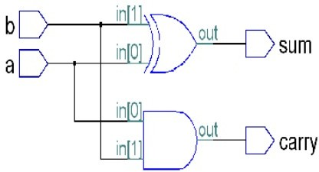
Fig. Logical Diagram of 1-Bit Half adder Equations of Half adder:

Sum = A XOR B Carry = A AND B

Bit Full Adder:

A full adder adds binary numbers and accounts for values carried in as well as out. A one-bit full adder adds three one-bit numbers, often written as A, B, and C_{in}; A and B are the operands, and C_{in} is a bit carried in from the next less significant stage.

Truth Table and Logical diagram of 1-Bit full Adder:

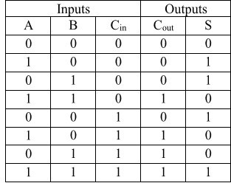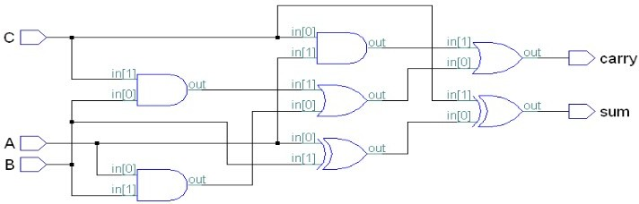

Fig. Logical Diagram of 1-Bit full adder Equations of 1-bit full adder:
Sum = A XOR B XOR C
Carry = (A AND B) OR (A AND C) OR (B AND C)

PROCEDURE:
  - Write a VHDL code for Half adder/Full adder.
  - Check syntax for syntax errors if any.
  - Synthesize the code using XST tool and generate RTL schematic.
  - Simulate the VHDL Code of Half adder/Full adder using Isim Simulator of Xilinx.
CONCLUSIONS:

